GB 21–22 3
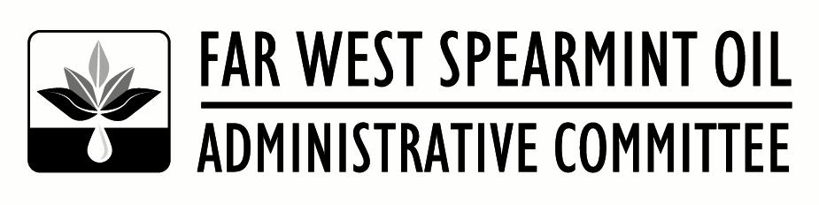
6601 W Deschutes Ave, Suite C-2,
Kennewick, WA 99336
Office: (509) 585-5460
Fax: (509) 585-2671

September 7, 2021

TO: All Growers, Handlers, and Interested Parties
SUBJECT: Area Grower Meeting Schedule, Golf Tournament & Dinner, Administrative Committee Meeting

Area Grower Meeting
We will be holding area grower meetings the week of September 27th. Enclosed is a schedule for the area grower meetings.

Area grower meetings are very important meetings in that they give every grower the opportunity to voice their input concerning the salable percentages to their Committee representative.

Please note the areas that Committee Member and Alternate Members nominations will be held. If you are a grower in any of these areas that will be holding nominations, and have a desire to serve on the Committee, please let me or your Committee representative know. We strongly encourage anyone interested in participating on the Committee to come to the meetings and seek to be nominated. USDA has asked that, where possible, we expand the nominees to include “women, minorities, those who are physically disabled, those who have not previously served as a member or alternate on the Committee, those representing organic or non-conventional farming, and those who represent farms defined as small businesses”.

Salable Committee Meeting – NOTE THE LOCATION CHANGE
The Far West Spearmint Oil Administrative Committee will meet on Wednesday, October 13, 2021 at the Nampa Civic Center in Nampa, ID (311 3rd St., Nampa, ID 83651). The meeting will begin at 9:00 am with the main agenda item being the setting of the 2022-23 salable percentages. There is a room block available at the Best Western Peppertree Nampa Civic Center. The rate secured is $109.00 per night plus taxes and fees. To book you room at this hotel call (208) 936-2222 and tell them you are with the Far West Spearmint.

Golf Tournament and Dinner
We will be holding our Annual Far West Spearmint Golf Tourney and Dinner on Tuesday, October 12, 2021. The golf tournament will be held at TimberStone Golf Course in Caldwell Idaho starting at noon. Dinner will follow the Golf Tournament at Indian Creek Steakhouse in Caldwell (711 Main St., Caldwell, ID 83605) at 6:00pm. Enclosed is a copy of the registration form for the Golf Tournament and Dinner. Please fill out the form and send it with payment to the Far West Spearmint office at the address above. Note - you don’t have to golf to eat, or eat to golf. Participate in whichever activities you are interested in.

Please refer to www.farwestspearmint.org for the latest statistics, bulletins, etc. The website is being updated on a regular basis.

Best Regards,
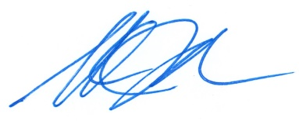
Shane Johnson
Manager

