GB 21–22 2
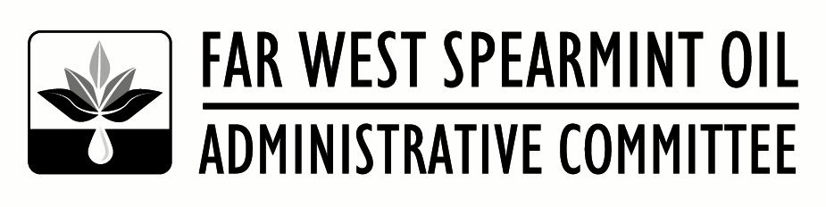
6601 W Deschutes Ave, Suite C-2,
Kennewick, WA 99336
Office: (509) 585-5460
Fax: (509) 585-2671

August 23, 2021

TO: All Growers, Handlers, and Interested Parties
SUBJECT: New Base Drawing, Area Grower Meetings, Saleable Meeting and Golf Tournament and Dinner

New Base Drawing
The Far West Spearmint Oil Administrative Staff held the 2021 New Base Drawing on Friday, August 20, 2021. In attendance were Manager Shane Johnson and Ag Association Management Staff member Megan Johnson. The following growers were drawn:
Class 1 (Scotch) Class 3 (Native)
Ryan Roedel, Mabton, WA Titus Bowser, Othello, WA
Roger Schober, Nampa, ID Kevin Tuckness, Homedale, ID

Area Grower Meeting
We will be holding area grower meetings the week of September 27th. I will finalize the dates and locations for these meetings in the next few weeks and get the schedule out in a separate Grower Bulletin. There will be open Committee positions beginning in January 2022. Nominations for these positions will be held at the Area Grower meetings. If you are a grower and have a desire to serve on the Committee, please let me or your Committee representative know. We strongly encourage anyone interested in participating on the Committee to come to the meetings and seek to be nominated. USDA has asked that, where possible, we expand the nominees to include “women, minorities, those who are physically disabled, those who have not previously served as a member or alternate on the Committee, those representing organic or non-conventional farming, and those who represent farms defined as small businesses”.

Salable Committee Meeting – NOTE THE LOCATION CHANGE
The Far West Spearmint Oil Administrative Committee will meet on Wednesday, October 13, 2021 at the Nampa Civic Center in Nampa, ID (311 3rd St., Nampa, ID 83651). The meeting will begin at 9:00 am with the main agenda item being the setting of the 2022-23 salable percentages. There is a room block available at the Best Western Peppertree Nampa Civic Center. The rate secured is $109.00 per night plus taxes and fees. To book you room at this hotel call (208) 936-2222 and tell them you are with the Far West Spearmint.

Golf Tournament and Dinner
We will be holding our Annual Far West Spearmint Golf Tourney and Dinner on Tuesday, October 12, 2021. The golf tournament will be held at TimberStone Golf Course in Caldwell Idaho starting at noon. Dinner will follow the Golf Tournament at Indian Creek Steakhouse in Caldwell (711 Main St., Caldwell, ID 83605) at 6:00pm. Please put these dates on your calendar. More information and registration forms will be sent out with the next Grower Bulletin.

Please refer to www.farwestspearmint.org for the latest statistics, bulletins, etc. The website is being updated on a regular basis.

Best Regards,

Shane Johnson
Manager

